Music Class Overview

Mrs. Flick

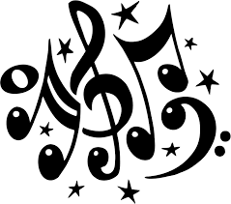

Your Middle School General Music class grade is based on Performance, Participation, Classwork and NSD assessments; helping you meet the Pennsylvania State Standards for Music Education:

PA STANDARDS FOR MUSIC:

1. Singing, alone and with others, a varied repertoire of music.
2. Performing on instruments, alone and with others, a varied repertoire of music.
3. Improvising melodies, variations and accompaniments.
4. Composing and arranging music within specified guidelines.
5. Reading and Notating Music.
6. Listening to, analyzing and describing music.
7. Evaluating Music and Music performances.
8. Understanding relationships between music, the other arts and disciplines outside the arts.
9. Understanding music in relation to history and culture.

Some ways we will accomplish these standards:

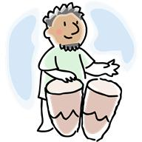 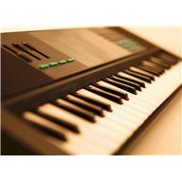   

Performing music in a variety of ways Listening Examples Technology

**GRADING:** Students will be graded for participation activities; class assignments quizzes and performances. Students earn points for each item. All points earned in a marking period are added together for an overall average: A = 90-100% B= 80-89% C = 70-79% D = 60-69%

**PERFORMANCES**: two attempts are allowed per performance, with the better attempting counting towards the grade.

**EXTRA HELP** is available by appointment before or after school. Email: [dflick@neshaminy.org](mailto:dflick@neshaminy.org)

**HOMEWORK:** there is no homework for music class, but students are able to take home their folders or use canvas to practice at home for performances or study for tests.

*How we SOAR at Poquessing,*

*be:*

*Safe * Organized * Accountable * Respectful*

Specifically….

1. Be on time and be prepared.

*Pencil or erasable pen, headphones when needed and your folder.



2. Participate fully in all class activities and assignments.

* Music helps your mind grow and function better—don’t waste that!

* Ask questions when you don’t understand!

* Come to clinic Wednesday or Friday morning as soon as you need help!

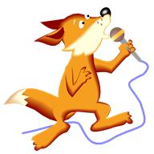  

3. Support your learning process.

* Success here is dependent on effort, not talent.

 You don’t have to be a rock star, just try! 

Did you know??

In 2015, when a major business magazine asked employers what skills they most need their employees to have. These are the top 10 they gave, in order of importance:

1. Ability to work in a team structure.
2. Ability to make decisions and solve problems.
3. Ability to communicate verbally with people inside and outside an organization.
4. Ability to plan, organize and prioritize work.
5. Ability to obtain and process information.
6. Ability to analyze quantitative data.
7. Technical knowledge related to the job
8. Proficiency with computer software programs
9. Ability to create and/or edit written reports

10. Ability to sell and influence others

(Source: Forbes.com, “The 10 Skills Employers Most Want in 2015 Graduates”)



So, we will be working in pairs and groups a lot in music this year. Getting along with other people can be tough sometimes!  Here are some strategies to help you get along and get things done.

1. Use basic good manners.
2. Notice and sincerely praise what other group members do well.
3. Understand that everyone in the group has something to contribute. Everyone does better when everyone participates.
4. Listen to your group members.
5. Work to everyone’s individual strengths.